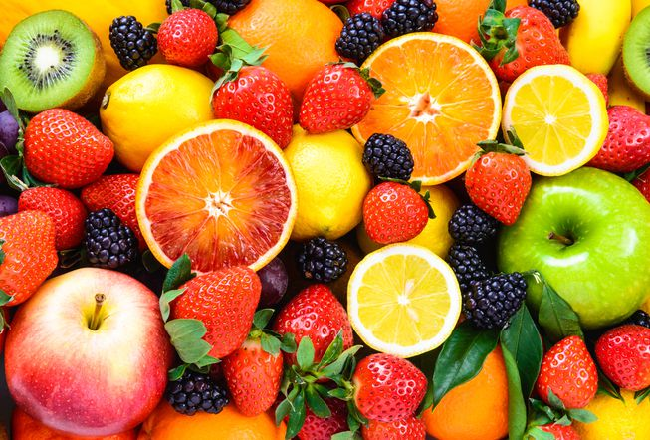

**Chiwen Shi**

**Shuhao Xia**

**Wensong Liu**

**Ying Lu**

**Fruits 360 Dataset Analysis**

**By**

**Group 7**

**Overview**

In most cases, when we try to log in or register a new account in a system, we have to enter verification code or select some specific kind of pictures to certify that we are not robots. Trying to train the model on how to distinguish a certain kind of pictures can help it verify whether the user’s verification information is correct in a more accurate way.

**Objectives**

We have a dataset of images containing fruits, there are 81 kinds of fruits in total. Our goals for the analysis of the fruit dataset is as follows:

* Given a specific picture, the model can identify which kind of fruits is and give the name of the fruits.
* From a set of pictures, the model is able to filter out all the eligible images of a certain kind of fruits according to the specific requirements.

**Dataset**

* Data sources: <https://www.kaggle.com/moltean/fruits>

The fruits dataset contains 55244 images in total, and 41332 images(one fruit per image) for training set, 13877 images(one fruit per image) for test set. There are about 45 images that contain more than one fruit per image.

**Use Cases**

**Web systems and mobile applications**: all the web systems and mobile applications that requires log in verification can use our model. It can help them programmatically verify whether the user is a robot or not.

**Workflow**

Basically we have split our data analysis process into four parts, the first part is to preprocessing the dataset, and then do the exploratory data analysis part. After that, we will finish model building and evaluating part, and then make a pipeline as well as dockerize the whole project. Our workflow is as follows:

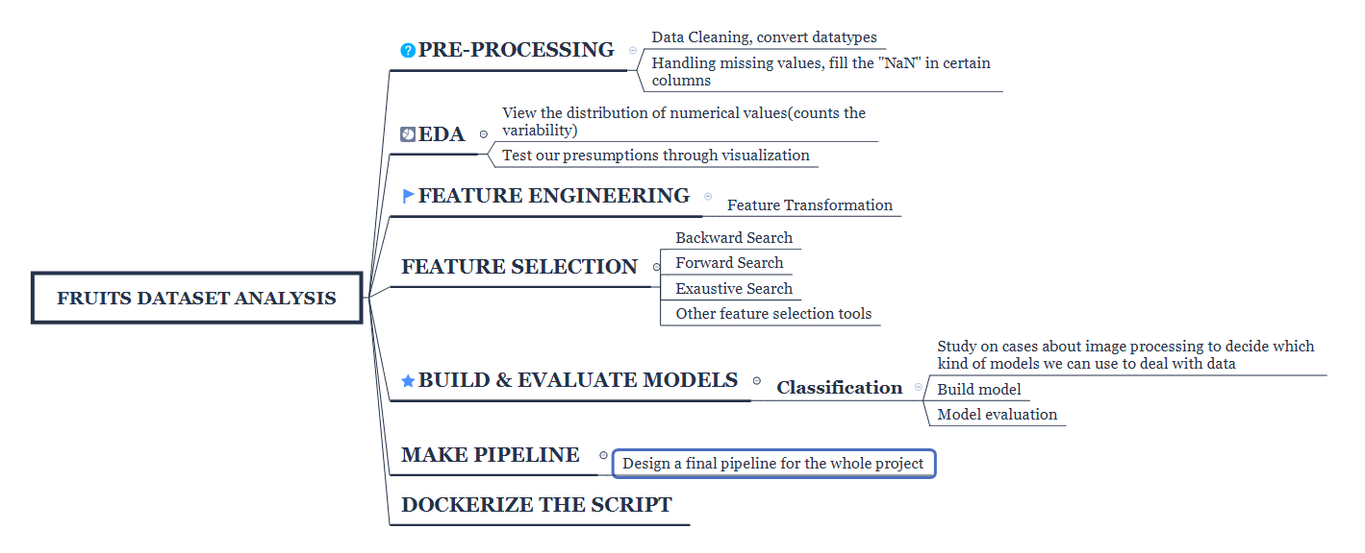

* Data Wrangling: data cleaning, handle missing values, convert datatypes
* Exploratory Data Analysis: view the correlation between different features and test our presumptions through visualization
* Feature Engineering & Feature Selection: To decide whether we need to do feature transformation using different methods and feature engineering tools, such as backward, forward search. Filter out important features through feature selection.
* Model Building: build models and evaluate the models.
* Final Pipeline: design a final pipeline for the whole project and dockerize the script.

**Timeline**

|  |  |
| --- | --- |
| **Timeframe** | **Work** |
| 2018.12.01-2018.12.03 | Data Preprocessing, Exploratory Data Analysis |
| 2018.12.04 | Feature Engineering & Feature Selection |
| 2018.12.05 -2018.12.07 | Model Building, Evaluating and Selection |
| 2018.12.08 -2018.12.09 | Final Pipeline and Dockerize the whole project |